FSSB Software Engineering Process Change Request
Date: | Feb 21, 2019 |  | Change Request Number:  (may be completed by process facilitator) |  |  |  |  | FSSB-019
Title: | Update Requirements Process
Initiator: | Keith Boadway
Proposed Change (additional pages/electronic files may be attached and/or referenced):
Requirements Process Flow
1. Rename “Define Requirements” to “Determine Customer Expectations”
2. Add new action box “Define and Prioritize Requirements”
3. Add new planning-related action box “Obtain SW Team Commitment”
4. Add new action box “Establish Requirements Traceability”
5. Change heading from “Define Requirements” to “Develop Requirements”
6. Change heading from “Maintain/Update Requirements” to “Manage/Update Requirements”
7. Add hyperlink for a Project SW Requirements (Template)
8. Change action box from “Identify Requirements Change Request” to “Identify Change Request (Requirements)”
9. Change action box colors for 3 Configuration Management (CM) related actions to CM gray color and add smaller note underneath that reads: (Gray boxes = Configuration Management activities)
10. Add hyperlink for a Project Requirements Traceability Matrix (Template)
11. Incorporate screen tips for the action boxes and provide hyperlink to open all SCM screen tips
12. Add “& Fix Issues” to the Peer Review Requirement action box
Requirements Description
13. Update the Requirements Description slide to be consistent with the process flow outputs and terminology
Peer Review: Requirements
14. Update the Requirements Peer Review Criteria to address the items required by the Project SW Requirements (Template) and CMMI v2.0
Rationale/Reason for why the change should be made:
1. Better association to RDM 2.1 Elicit stakeholder needs…
2. Includes RDM 2.2 needs to establish “prioritized customer requirements”
3. Includes RDM 2.4 “obtain commitment from project participants that they can implement…”
4. Initializes the product to implement RDM 2.5 “maintain bidirectional traceability…”
5. Better alignment with CMMI RDM process terminology and emphasizes more than req. definition
6. Better alignment with CMMI RDM terminology
7. Provide FSSB resource for projects creating software requirements documents
8. Better explains that changes to requirements don’t require a special change request, but can be covered within existing CM change requests
9. Visually associates the actions to CM and will be reinforced using the screen tips
10. Provide FSSB resource for projects to help trace requirements
11. Provides lower level descriptive information for consistency and better edification
12. Clearly show that issues are fixed as part of the peer review process
13. Consistency
14. Consistency and compliance with CMMI v2.0
Process User’s Group Recommendation:
Branch Head: Approve / Disapprove |  |  |  |  | Date:
Change Management:
Changes Made: |  |  |  | Made by: |  |  | SVN Number:

6 Attachments
- FSSB Software Engineering Process Requirements Process Flow
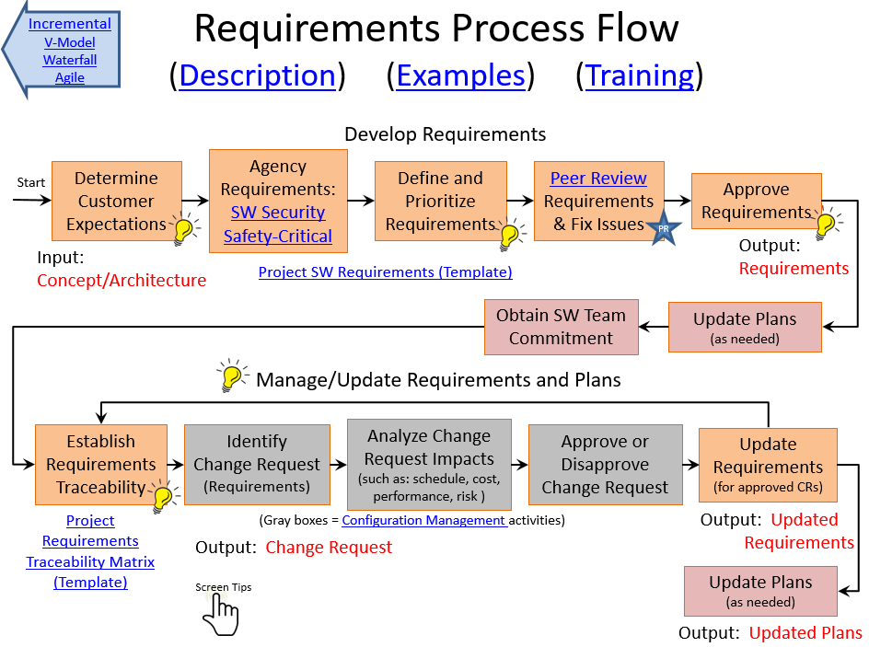
- FSSB Software Engineering Process Requirements Description
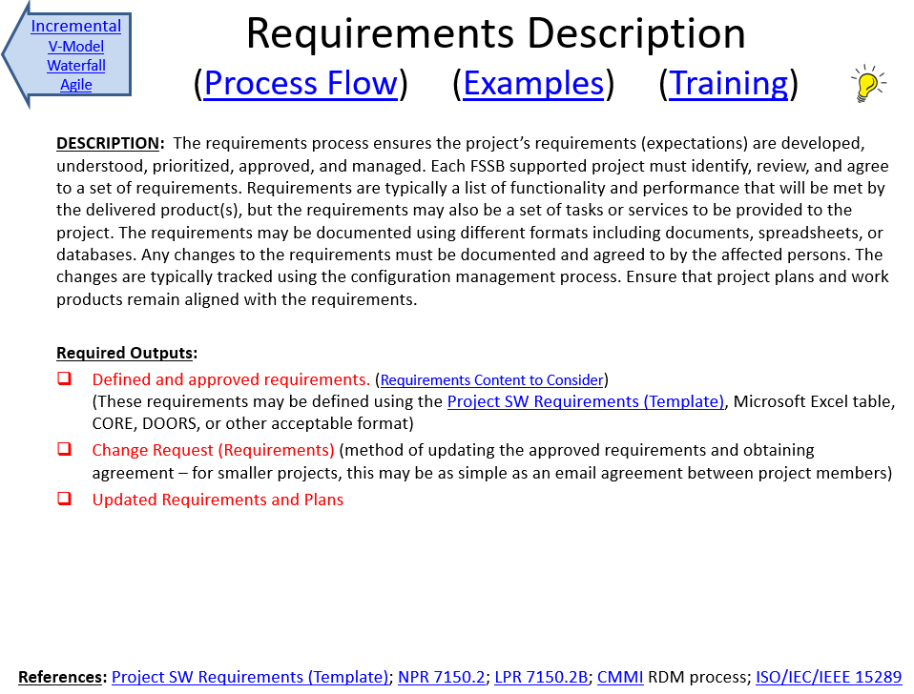
- FSSB Software Engineering Process Requirements Lessons Learned
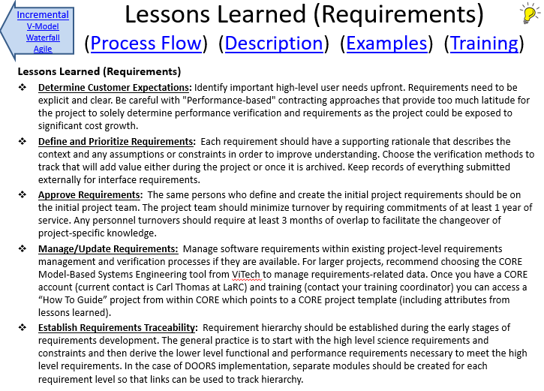
- Project SW Requirements (Template).docx
(attached via separate file)
- Project Requirements Traceability Matrix (Template).xlsx
(attached via separate file)
- Requirements Screen Tips.docx
(attached via separate file)

